General: Reflection Questions to ask after people participate in team building events:
- What did you learn about yourself?
- What did you learn about the team?
- What would you do differently?

Icebreaker Questions to Get to Know Your Team

Most teams want to feel connected with their colleagues. One way to build relationships is to facilitate a short icebreaker questions at the beginning of team meetings or even in the middle of a longer meeting. All you need is an interesting (and safe) question to learn new things about each other.
Icebreaker Questions can be thought-provoking, reflective, creative, or funny. Choose a question appropriate for your team meeting and invite everyone to answer. Here are some questions to get you started.

Fun & Light:
- What was your nickname and why?
- What was in your high school locker?
- What's your favorite tradition or holiday?
- What is something you've done that no one would expect?
More Vulnerable:
- Do you have a personal hero? Who/why?
- What book has influenced you greatly? How?
- As a child, what did you want to be when you grew up? What was the dream/inspiration?
- When was last time you were moved to tears and why?
Deep Questions
If you want to build trust and learn about each other in a meaningful way, choose a deep question. These questions are more serious and may require more time to answer. It may be helpful to share the question prior to the meeting, so the team members have time to think about how they will respond. Ideally, you give each person at least two minutes to respond during the meeting, including time for the team to ask follow up questions.

- What do you need right now?
- What experience have you had where everything changed in the blink of an eye?
- What is the biggest trigger for stress in your life?
- What have you accomplished in the last year that you are proud of?
- Why do you think some people are successful in life and others are not?
- In what way are you strong?
- What item do you own that is not worth much money but has great value for you?
- How do you strive to be similar to, or different from, you parents?
- What did you get in trouble for a kid and how has that experience impacted you to this day?

Fun Questions
If you are looking for a quick, light-hearted icebreaker, choose a fun question. The responses to these questions will be shorter and possibly funny. They typically don’t require as much time to answer and there is not much, if any, need for follow-up questions. Use these when you want a fast-paced energizer.
- What are you looking forward to this week?
- If you had been able to choose, would you rather have been an only child or part of a very large family?
- What color do you feel like today?
- If you were going to get a new tattoo, what would you get?
- What traffic sign best reflects your life right now?
- Which section in the bookstore are you most drawn to?
- What celebrity would you like to have dinner with?
- If you could instantly have one talent that you do not naturally have, what would it be?
- What is your favorite game to play?

Summary
A brief round-robin style icebreaker at the beginning of a team meeting can build rapport and energize your team. Choose a question that is appropriate for your team’s level of trust and also the amount of time you have in your meeting.
Source: These questions are adapted from the book, 300 Writing Prompts, published by Piccadilly Inc.

Other questions provided

- What is your walk-out song & why
- If you weren’t doing this job – what would you be doing and why
- What’s your call sign (Maverick – Tom Cruise)

Bag of Questions

Used a Google sheet for this - since we had a large number of web participants. We have a tab with over 300 general questions. The spreadsheet would randomly pick two of those questions for participants to answer in a small group setting

One Question!

You give a situation (hiring a nanny, answering a marriage proposal, considering a job offer), and, in pairs, your folks come up with what they would ask if they were allowed only ONE question in order to decide…

Questions
Give them curiosity questions and then putting them in as many pairings as possible in a short period of time. Make it like a game, like speed dating. The game is that they have to pair up with as many people as possible (no repeats!) over the length of the exercise. Start with everyone standing and milling about. You pose the question and time it (you could do the same question over 3-5 rounds, or a few questions with a couple of rounds each). Give each pair 1 minute (30 sec per person) to answer. Keep everyone standing (if able) throughout the exercise. The key is to make the questions fun and interesting (or perhaps more vulnerable disclosures, if going for high trust) and relevant for your overarching goals.
Let me know if this resonates and if you want sample questions to kickstart your brain.
Carol

Little-Big is an icebreaker you can use to kick off a meeting or training session. This quick team building activity connects and energizes a team.
You can adapt this concept and use this icebreaker in a variety of contexts. This short icebreaker will stimulate positive feelings and allows them to learn a little about each other.
I simply put up a slide with an image of a little dog beside a big dog and asked them to each share just ONE little and ONE big thing that brought them pleasure or de-stressed them. I gave them my personal example and within 3 minutes, all 9 people had shared. Most were smiling at the end of this because thinking about those things stimulated the pleasure centers in their brains. Now they were in a more positive mood to begin an intense evening session together.

You can modify this “little-big” concept in a variety of ways, such as ONE little and ONE big…
- Thing that brings you pleasure/de-stresses you
- Idea for our team
- Thing you appreciate about your team/work
- Thing you’d like to learn more about
- Action that demonstrates leadership

Instructions:
- Create a slide with a fun image of something little and big. (I used an image of dogs, perhaps you can pick an image that connects to the topic or the team’s work, be creative).
- Give the instructions that they are to share ONE little and ONE big thing. Tell them they will only have 30 seconds to report out.
- Provide them up to 1 minute to think about what they will share.
- One at a time, ask each person to share.

Five Things Team Building
Five Things is a fun networking activity you can do in person or online. Networking isn’t everyone’s cup of tea because it can be challenging to get the conversation rolling. Providing a simple task for the group provides an immediate topic of discussion which removes the uncomfortableness about what to say first.
Below are the instructions for Five Things that will work in person or in online groups of all sizes. If online, you will need to use a platform, such as Zoom that allows for breakout rooms.

Instructions:
- Divide the group into small groups of 2-5 people.
- Tell the groups they have “x” minutes to discover 5 things they share in common.
- Challenge them to be creative and not just go for the obvious things.
- To debrief, ask each group to share the most interesting thing they all have in common.

Hints for facilitating this engagement:
- Consider the amount of time you have for this activity when choosing the size of the groups and the amount of time they have. You will want to put some pressure on the group in order to do this quickly. The larger the group, the longer it will take to find five things.
- This could be done in several rounds with 2-3 people. In this adaptation, they will get to mix and mingle with more people.
- Encourage them to follow up with each other later to talk more about their commonalities.

Summary
Providing light structure while networking takes away the awkward pressure of making conversation with someone you may not know at all. Five Things is a fun networking activity that connects people on their commonalities and opens the door to follow-up conversations later as well.

Keys to Our Success Team Building
The more your team focus on key behaviors and values that drive team success, the more likely they are to get there! This adaptable activity is both tactile and designed to reinforce positive behavior and workplace success. You can use this in a variety of ways to allow people to think about “the keys of” the topic of your meeting.
First, facilitate a discussion to capture their key behaviors or values, write them on a tag and attach them to a key. Then, each person then gets to keep their key and put it somewhere as a visual reminder. For example, on their desk.

Supplies:
All you need is a set of keys and tags (Avery #11026, Split Ring Key Tags). I got both off Amazon for less than $15 – and I have enough for 30 people.

Instructions:
Here are some ideas on how you can use this activity with your team.
1. The Key to Our Team’s Success
Begin with a robust discussion about what it will take for your team to have “success.” Be sure you define what success is first. For example, it might be reaching your annual goals or it might be about the culture the team wants to create. After your discussion, choose one of the options below:
Option 1: Get the team to narrow the list of key behaviors to 1-3. Each person then writes those 1-3 behaviors on the tags and attaches them to a single key. (Each person gets a key.)
Option 2: After listing the behaviors for the team, each person selects 1-3 key behaviors they will promise to exemplify. In this option, each person on the team may choose different words or phrases for their key. Ask each person to share their promises with the team.
2. The Key to My Success
This can be done as a group activity, or during a one-on-one coaching conversation. After a discussion on key values and/or behaviors that the person wants to exemplify, ask them to write 1-3 down on tags and connect the tag(s) to a key to keep as a reminder. If this is a group activity, as each person to share their tags with the team.
This is an easy, fun and memorable way to consciously choose what to focus on and have a reminder.

Hope Team Activity
Hope is a critical human emotion. It gets us through tough times and inspires us to do better. In times of change and turmoil, spending time thinking about our hopes can help us re-frame our thinking towards a more positive future. When clarified hopes are backed by actions amazing things can happen.
This simple team activity was used with a team as they met in June of 2020. History will show the first half of 2020 was to say at the very least, stressful and overwhelming. Recently, I wanted to connect a team in a way that got them looking forward and clarifying what they desired for the last months of the year. I asked the following question and left it open to interpretation:
What is your hope for the remainder of 2020?
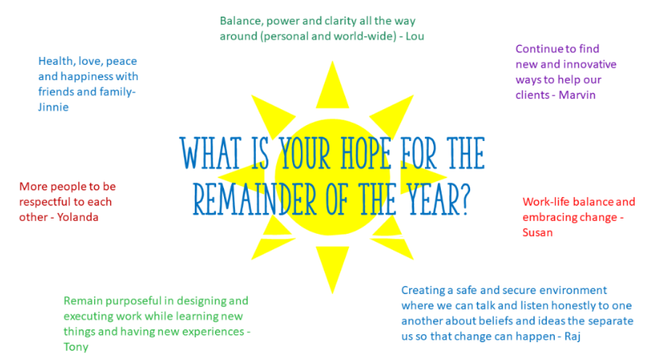

Then, I gave them 2 minutes to journal their hopes independently. Eagerly, I waited to see what they would share with the team. After two minutes, I asked them to annotate on a slide board (see example above). Then, I asked each person to share their hope plus ONE small action they would take to activate their hope.
I was touched by their openness and the common themes that emerged. Many hoped about peace and coming together with others.

Instructions
- Ask everyone to answer a question about hope, such as: What is your hope for the remainder of the year?
- Give them 2 minutes to independently journal.
- Using a shared whiteboard or annotation tools, ask them to type their hope on the board.
- Go around and ask each person to share their hope and one way they will activate it.
- Screen shot the board and share it with the team.

Adaptations
This could easily be adapted based on the team and timing. Here are some examples of ways you could modify the question:
What is your hope… (choose one from the list below)
- …for our team for the remaining fiscal year?
- …for the next quarter?
- …as we transition to working back in the office again?
- …for your future career?
- …for this team?
- …for this project?
- …for our clients/customers?

Summary
This activity gives team members the opportunity to focus on hope and then share their hope in ways to activate them. This simple team building activity also opens the meeting or discussion by shifting the participants into a positive state of mind.

People Bingo

Fill a bingo card with prepopulated items that the group has sent in beforehand (e.g., I drive a Jeep, I have 2 cats, etc.). The group has to find the person that connects with the item in the squares (when they find the person they can initial the square for them). Traditional bingo rules apply – the first person to get a full line signed is the winner

Fill a bingo card with random things that might be common about people (# of siblings, having animals, etc.) and do the same thing as above where people just look for people with those items. Apply traditional bingo rules.

Zombie Cats

I have used this method in workshops where we have groups of people at a table who will be co-creating. I cannot recall where I "borrowed" this from...but it was fun.
WARM-UP ACTIVITY:
Steps:
1.Using (5) post-it notes, write your (5) favorite things; foods, animals, events, activities, vacation spots, etc. (1) per post it
2.One at a time…introduce yourself; "Hi, my name is…. And these are (5) of my favorite things."
3.Goal: table to come to an agreement on (2) things everyone likes....and that is your table team name.
i.e. Zombies & Cats = Zombie-Cats....Pizza - Puppies, Sushi-Sailors, Movie-Golfers, etc.......

Polling

One activity that is always a winner is creating a quiz using Poll Everywhere (https://www.polleverywhere.com). We use this to test for knowledge retention as the end of a training but you could create this as a way for your delegates to find out more about one another or just break the ice. Delegates play off against one another. The first person to get the answer right in the quickest time gets the highest points and this then goes down for second fastest etc. At the end of each question they see their ranking and compete to get ahead. You could select basic trivia questions or questions specific to industry or organization. But Its a great way to break the ice. And delegates can use their mobile devices to participate or their laptops - they simply click or type in a link to join the poll.

Personality Tests

Personality type tests so that you can learn more about a person & how they approach problems or how best to work with them etc.

Privilege exercise

Ask a series of questions asking people to step forward or back according to their answer/experience.

Zoom background
There's been some good interaction in some meetings where they change their zoom background (ie. fantasy vehicle, favorite childhood toy, least favorite food, most annoying movie on repeat, favorite band, etc).

Assembling Kits for Non-Profits

Trivia Event
There is a guy in Iowa City that will facilitate a trivia event for your group.

Themed Meetings
Conduct a themed meetings/events -- where food/clothing/phrases needed to be used.

Tower Building
Index Cards
For the tower build use regular index cards...there was 2 runs, first run you couldn't talk, 2nd one you could
Found these directions online:
https://teachersareterrific.com/2017/03/index-card-towers.html

Puzzle
Use puzzles for 4 year olds with all the pieces in a bag... then 1 piece from each puzzle was put in the other bag. then each team raced to the fastest puzzle completion. The message was that you had to cooperate with other teams even though you were competing with them

Two Truths & a Lie

People tell three things about themselves, 1 is a lie and 2 are true – the group must figure out which is which

​Three Unique Things About Me

People give the facilitator 3 unique things about them and throughout the event the facilitator shares them, and the group has to guess who the person is

​
Bushfire/stranded in the dessert exercises are good
​
First individually, then again as a team to show how that improved your survival. (most people improved with a team, there was usually an outlier though)
​
you get a list of supplies and rank them according to importance for your survival. then you calculate the error of your ranking from what the expert's ranking

Blind Drawing

One person is drawing and the other person is looking at the shape/picture they are supposed to replicate, and they stand back-to-back with person 2 describing the shape as person one tries to carry out the instructions…

Dare Jenga

For: Team Bonding & Ice Breaking

What you'll need: A Jenga set (preferably with large blocks)

Instructions: This one is a fun team building icebreaker for work that will get your team to test their limits. Write a dare on the surface of each block. Make them fun dares around the office such as: do 15 pushups, sing "Twinkle, Twinkle, Little Star" out loud, or wear the oversized sombrero for the rest of the work day (yes, we have an office sombrero). When all the blocks have dares on them, stack them up like in Jenga. When people pull a block out, they have to perform the dare that's written on it.

Line-up According to Birthdate

A quick and dirty ice breaker is to have them line up according to birthdate…

BIRTHDAY LINE-UP
OBJECTIVE: This simple team-building exercise instills qualities like leadership, communication, collaboration, and problem-solving skills.
TIME: 10-12 minutes
TOOLS: None required
PARTICIPANTS: 12-20
HOW TO PLAY: Pair participants into teams of 8-12 and ask them to stand side-by-side. Now ask them to stand in order of their birthday (month and day). The catch to this simple game is that employees have to complete the entire task without talking to each other. They must use signs and symbols to get into order.
The team which is able to get into order successfully the earliest wins.

Music Challenge

If you have techie ability, have each person send you a clip of their favorite song, play them throughout the meeting, and have the team try to guess which belongs to whom…

Marshmallow Challenge

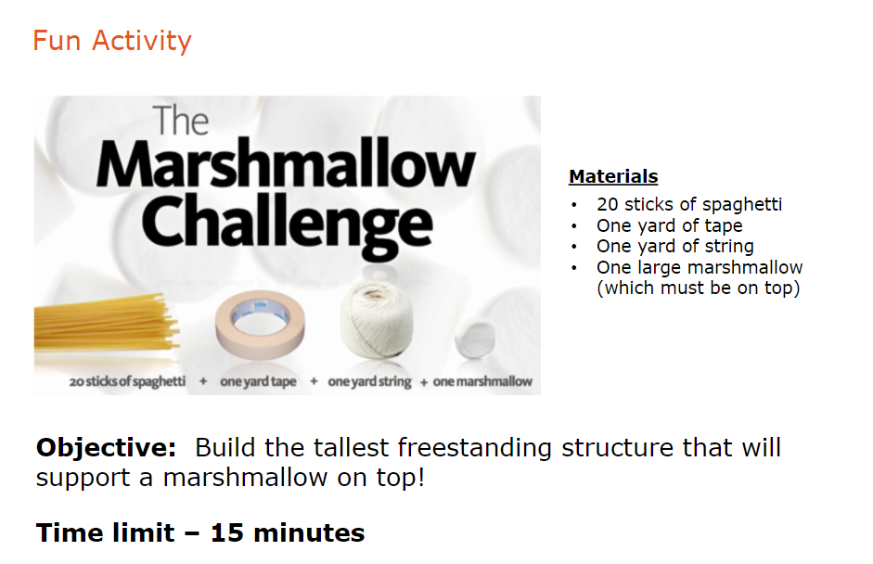

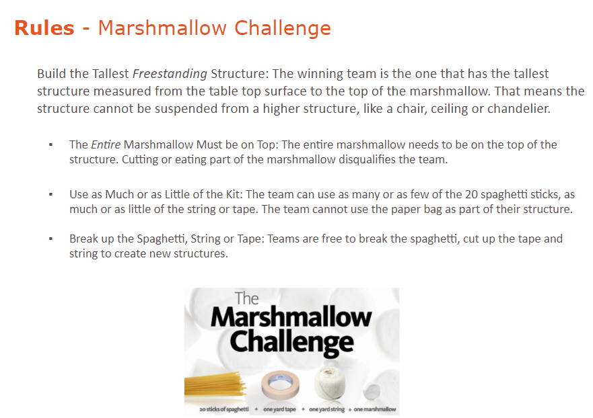

Following Directions Activity

Attachment: ABC123 PowerPoint slides

Note: Each team should collaborate with another team to complete this activity. Depending on the size of the class you may need more than one set of materials (pairs of teams) to perform this activity simultaneously. The activity requires 10 people (5 per team). If teams have more than 5 people, designate the extra people as customers or a director to manage the movement of the team.

EQUIPMENT (per group): Eleven spaces (carpet squares or paper sheets), one for each person (10) (even numbers of people) plus one extra (making for an odd number of spaces). A Set of cards label 1-5 and another set of cards labeled A-E.

SET UP: Place the odd number of spaces in a line and stand on the center space. Invite group members to occupy the remaining even number of spaces and ask them to turn to face you in the middle. Give each participant one of the labeled cards so that they are arranged in the following pattern:

Then step off the middle space.

TASK; to change places with one’s corresponding cross partner (A-1, B-2, C-3, etc.) without breaking any rules.

SAFETY; If people look like they will lose their balance from treading carefully, then permit temporary step offs.

Allow 20 minutes for this activity

INSTRUCTIONS (Share the following with participants)

Say:

In most organizations, people work toward different goals by different means, but must utilize shared rules and resources to achieve those goals.
In this activity, we’ll emulate that type of setting by imaging that the two sides (indicated by Numbers and Letters) are attempting to reach their goals (represented by the exchange of places) and to do so, they must share resources (represented by the spaces) and follow the same rules.

Let’s review the list of rules:

RULES:

- You can only move forward (you cannot move backwards).
- You must remain on a space (you cannot step off to have a discussion).
- You can only move into open spaces (cannot occupy spaces that others are on).
- You can only move around a person from the opposite side into the next open space (cannot move around your own side’s member).
- You can only move around one person at a time (cannot move around two or more people who block you).
- Only one person may move at a time (two or more people cannot move simultaneously).

Any Questions?

As the teams perform this activity, you may need to aid. The Click to open activity presentation link on this slide will open another PowerPoint presentation that animates a step-by-step solution to this problem. You can also refer to the diagram on the last page of this section of this Instructor Guide.

As the teams perform this activity, you may need to provide assistance. The Click to open activity presentation link on this slide will open another PowerPoint presentation that animates a step-by-step solution to this problem. You can also refer to the diagram on the last page of this section of this Instructor Guide.

When the activity is competed:

Select the Click to open activity presentation button and walk the class through the solution, point out the places where if the teams just moved forward towards their own goal, the process breaks down and neither team can move forward. Only by considering the needs of both teams can we arrive at a solution.

Ask the participants to identify how the activity relates to challenges they face in their day-to-day working environment.
- Differing department goals with a need to utilize shared resources to obtain them.
- Competing departmental goals interfere with achieving over-all Material and Supply goals.
- Communication challenges create barriers to successful implementation and/or coordination of efforts.
- Vague knowledge of other working entities within Material and Supply, unknowingly cause; interruptions, barriers and inability of other units to accomplish their work.

Ask participants to identify various places where this partnership and/or collaboration should happen within the processes today, and offer their insight as to why it may not be occurring if it is missing.

Award team pairs that excelled (e.g. little or no help) at this activity 5 tokens. Award team pairs that required moderate help 3 tokens. Award team pairs that required extensive help 1 token.

Activity Solution

Below is a composite of the required moves to assist facilitation. An animated PowerPoint animated version of this diagram is provided via the Click to open activity presentation link on the activity slide.

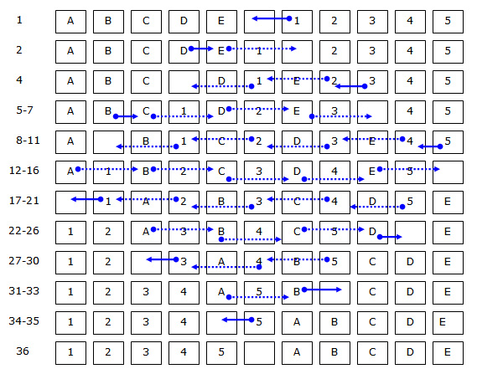

Paper Scraper

https://www.focusedldr.com/paper-scrapers

